**Exercise: Supernova – mass transfer in binary systems**

Given is a giant star with mass M and radius R and a white dwarf with mass m and radius r.  
The distance between the two stars is d.   
We want to do some calculations concerning the mass transfer between the two stars.

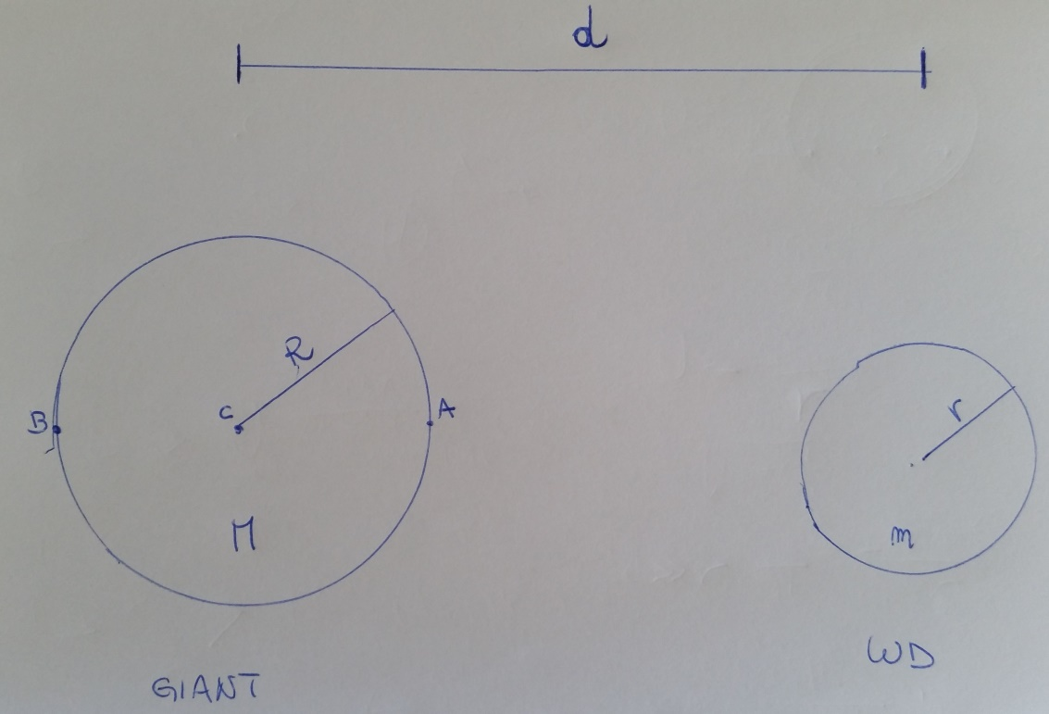

1. Calculate the gravitational acceleration due to the white dwarf at the three Points A, B and C on the giant star.  
   Use the following formula (x is the distance from the center of the white dwarf to point A, B or C)
$$g=\frac{GM}{x^{2}}$$

2. Proof that the acceleration at the points A and B relative to the center C of the giant star are in opposite direction and are given by

$$g'=\frac{2Gm}{d^{3}}$$

which is the tidal acceleration caused by the white dwarf on the surface of the giant start.

1. Calculate the work W done by the tidal force F=Mg’ in disrupting the giant star all along its diameter.
2. Compare this work with the self-gravitational-potential-energy of the giant star and demonstrate that if $d< \sqrt[3]{\frac{4m}{M}} R$ the work done by the tidal forces are able to disrupt the giant star. The tidal exaltet from the giant towards the white dwarf are neglectable because the white dwarf is too compact. This calculation shows that since the tidal force is able to disrupt the giant, it is also possible that this phenomenon causes the mass transfer towards the white dwarf.